**(CSCI 365) Project Eight Greatest Common Divisor**

**Objectives**

1. Implement Euclidean algorithm to find Greatest Common Divisor
2. Implement Euclidean algorithm using Recursive thinking
3. Apply loop
4. Apply recursive thinking
5. Apply Irvine32.inc library
6. Write user defined procedure and call user defined procedure

**Problem Description:**

The greatest common divisor (GCD) of two integers is the largest integer that will evenly divide both integers. The GCD algorithm involves integer division in a loop, described by the following pseudocode:

int GCD (int x, int y){

x = abs(x) // absolute value

y = abs(y)

do{

int n = x % y

x = y

y = n

}while (y > 0)

return x

}

Implement this function in assembly language. Then go online find its recursive version and implement it in assembly language too. Then write a test program that calls your two GCD procedure five times each, using the following pairs of integers (5, 20), (24, 18)_, (11, 7), (432, 226), and (26, 13). After each procedure call, display the GCD

You may refer to Programming Exercise #6 on page 285 and Programming Exercise #7 on page 350.

**Sample Run:**

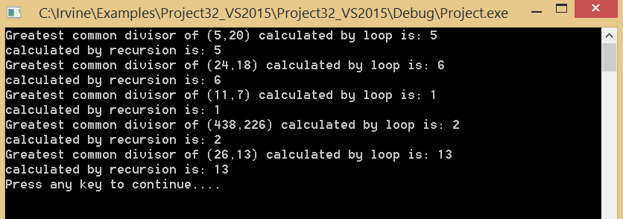

Due Date:

Turn in YourNameProj8.asm via Blackboard. Due date will be announce on Blackboard.